# The Role of Race and Mental Illness Diagnosis on Stigmatization of Homeless Individuals

Karen Veronica Becerra

MAPSS Psychology, Department of Psychology, The University of Chicago

# Author Note

Karen Veronica Becerra  <https://orcid.org/0009-0006-4967-0955>

Correspondence concerning this article should be addressed to Karen Veronica Becerra, MAPSS Psychology, Department of Psychology, The University of Chicago, 5848 S. University Avenue, Chicago, IL 60637, USA, Email: kvbecerra@uchicago.edu

# Abstract

Homelessness in the United States is a persistent problem that can have serious implications on the well-being of homeless individuals. The present study focused on the role of race and mental illness diagnosis on the stigmatization of homeless individuals, specifically looking at the outcomes of the Attribution Questionnaire. This questionnaire assessed the aspects of social distance, blame, dangerousness, concern, and willingness to help of 215 participants varying in ages across adulthood. The study was a self-paced online form that used six experimental vignettes. The results indicated that there were no significant interactions of race x diagnosis on stigmatization. Additionally, race had no significant main effects, suggesting it was not a significant factor for stigmatization of homeless individuals. However, there were some significant main effects of diagnosis. Findings might suggest that future work in reducing mental illness stigma and increasing education could help decrease stigmatization of the homeless population.

*Keywords*: Homelessness, Stigmatization, Race, Mental Illness, Diagnosis, Attribution Questionnaire

# The Role of Race and Mental Illness Diagnosis on Stigmatization of Homeless Individuals

Homelessness in the United States and the struggle to give individuals adequate housing is a persistent problem. Before the Covid -19 pandemic, the number of homeless individuals was on the rise with 568,000 individuals experiencing homelessness in 2019, an increase of 15,000 from the previous year(Frost, 2020). With the current Covid-19 pandemic, we can only predict that those numbers have continued to increase. In the United States, 2.4% of homeless individuals die each year (Stasha, 2020). We know that the general population often tries to distance itself from the stigmatized population, more specifically the homeless population. Homeless individuals face greater stigma and social isolation and often are removed from public parks and other locations because the general public does not want them too close. The problems caused by stigmatization, such as social distancing, can affect the homeless population in terms of resources that they have available such as sanitation centers, employment, and social support. Often the homeless population lacks resources and is exposed to the elements which can increase their mortality, as well as the chance of being malnourished, having parasitic infestations, periodontal disease, degenerative joint diseases, venereal diseases, cirrhosis, and hepatitis-related to intravenous (IV) drug abuse. Public attitudes toward homeless individuals can influence policies and the services provided to this population. The attitudes displayed through the stigma of homeless individuals can have an impact on both physical and psychological health and willingness to access services. The impact of these stigmas has shown to have serious implications on the well-being of homeless individuals. The present study examined factors that could predict levels of stigmatization expressed towards homeless individuals.

## Literature review

Research on the stigma of mental illness, homelessness, and race highlights its harmful effects on health and social integration. P. W. Corrigan et al. (2009) examined public stigma, focusing on stereotypes like causal attribution (blaming individuals for their condition) and dangerousness (perceiving them as threatening). Using vignette-based experiments, the study found that people with psychiatric disorders, especially those with drug addiction, faced greater stigma than those with physical disabilities, laying the foundation for understanding how schizophrenia and substance use disorders contribute to homelessness stigma.

While P. Corrigan et al. (2003) explored mental illness stigma, it did not examine health outcomes. In contrast, Weisz and Quinn (2018) demonstrated that homelessness stigma leads to psychological distress, poor health, and social avoidance. Among 175 volunteers at a homeless event, those experiencing or anticipating stigma reported worse physical and mental health and greater reluctance to seek services. Participants of color faced even higher distress and service avoidance, highlighting the compounded impact of race and homelessness stigma.

Building on this, Markowitz and Syverson (2021) investigated race and gender intersections in stigma. They found that black homeless individuals were perceived as more dangerous than white counterparts, though no significant differences in social distance emerged. However, the study’s reliance on college-aged participants, who may have been more tolerant than the general population, was a limitation. The present study addresses this by including a broader, more diverse sample.

Similarly, Gattis and Larson (2016) linked racial stigma and discrimination to heightened depression among 89 black adolescents and young adults experiencing homelessness. Using social and minority stress models, the study highlighted how marginalized groups face greater psychological distress due to limited societal support. Though constrained by a small sample, it reinforced the role of racial stigma in homelessness experiences.

In sum, stigma related to homelessness, mental illness, and race profoundly affects psychological and physical health, social integration, and resource access. The present study expands on this research by examining how mental illness and race interact to shape stigma, offering a more nuanced understanding of its impact on homeless individuals

## Current Study

Building on the research by P. W. Corrigan et al. (2009), Markowitz and Syverson (2021), and Weisz and Quinn (2018) the current study aimed to explore how race and mental illness diagnosis impact the stigmatization of homeless individuals. The research specifically focused on mental illness, distinguishing between individuals with schizophrenia and those with substance use disorders, and examined how these factors interact with race in shaping stigma. Previous studies suggest that public stigma varies across mental health conditions and that race plays a crucial role in determining the intensity of stigma. Based on these findings, the present study hypothesized that race would significantly influence social distance, perceived danger, blameworthiness, and emotional responses (concern and help) toward homeless individuals. Specifically, it was predicted that black homeless individuals would experience greater social distance, be perceived as more dangerous and more blameworthy, and receive less concern and help compared to their white counterparts. Additionally, it was anticipated that individuals with substance use disorders would face higher levels of social distance, dangerousness, and blame, while individuals with schizophrenia would receive more concern and help. Lastly, the study predicted that race and mental illness diagnosis would interact to influence all aspects of stigmatization.

### Hypotheses

#### Effect of Race on Stigmatization.

1. Black homeless individuals will experience greater social distance.
2. Black homeless individuals will be perceived as more dangerous.
3. Black homeless individuals will be perceived as more blameworthy.
4. Black homeless individuals will receive less concern and help compared to white homeless individuals.

#### Effect of Mental Illness Diagnosis on Stigmatization.

1. Individuals with substance use disorders will face higher levels of social distance.
2. Individuals with substance use disorders will be perceived as more dangerous.
3. Individuals with substance use disorders will be perceived as more blameworthy.
4. Individuals with schizophrenia will receive more concern and help.
5. Interaction Between Race and Mental Illness Diagnosis

#### Race and mental illness diagnosis interaction.

1. Race and mental Illness diagnosis will interact to influence all aspects of stigmatization, including social distance, perceived danger, blameworthiness, concern, and willingness to help.

# Method

## Participants

The sample for this study consisted of 215 participants, primarily college-aged students in the United States, with ages ranging from The ages of the sample ranged from 18 to 79 (M = 35.08, SD = 16.33).The sample was 44.7% White, 13% Hispanic, 33% Black, 4.2% Asian American, 3.3% Biracial, and 1.9% other ethnicities. The sample identified politically as 52.6% Liberal, 37.1% Moderate, and 10.3% Conservative.The sample was broken down into 1.9% living in a rural community, 58.6% living in the suburbs, 12.1% living in a small town, and 27.4% living in a large metropolitan city. Finally, the distribution of gender was as follows: 29.3% male, 68.8% female, and 1.9% other responses. **Table 1.** provides a summary of the demographic characteristics of the sample.

### Table 1

Demographic Information of Participants

| **Demographic** | **Percentage** |
| --- | --- |
| **Age (M = 35.08, SD = 16.33)** | - |
| **Ethnicity** |  |
| White | 44.7% |
| Hispanic | 13% |
| Black | 33% |
| Asian American | 4.2% |
| Biracial | 3.3% |
| Other Ethnicities | 1.9% |
| **Political Affiliation** |  |
| Liberal | 52.6% |
| Moderate | 37.1% |
| Conservative | 10.3% |
| **Location** |  |
| Rural Community | 1.9% |
| Suburbs | 58.6% |
| Small Town | 12.1% |
| Large Metropolitan City | 27.4% |
| **Gender** |  |
| Male | 29.3% |
| Female | 68.8% |
| Other Responses | 1.9% |

**Note**: Percentages may not sum to 100 due to rounding.

## Measures

This study used multiple questionnaires to examine the effects and interactions of race and mental illness on stigmatization toward homeless individuals. Participants were assigned to one of six experimental conditions using vignettes adapted from Markowitz and Syverson (2021), manipulating race and mental illness. **Table 2.** presents the vignettes used in this study.

### Table 2

Vignettes Used in the Study

| **Condition** | **Race** | **Mental Illness** | **Character Description** |
| --- | --- | --- | --- |
| Condition 1: Black character/No mental illness | Black | No mental illness | Male homeless individual with same life story |
| Condition 2: Black character/Substance use disorder | Black | Substance use disorder | Male homeless individual with same life story |
| Condition 3: Black character/Schizophrenia | Black | Schizophrenia | Male homeless individual with same life story |
| Condition 4: White character/No mental illness | White | No mental illness | Male homeless individual with same life story |
| Condition 5: White character/Substance use disorder | White | Substance use disorder | Male homeless individual with same life story |
| Condition 6: White character/Schizophrenia | White | Schizophrenia | Male homeless individual with same life story |

**Note:** All vignettes used the same life story for the male homeless individual, with only race and mental illness varying across conditions.

### Attribution Questionnaire

The Attribution Questionnaire(P. Corrigan et al., 2003) assessed stigmatization aspects like social distance, blame, perceived dangerousness, emotional response, and willingness to help.

### Memory Check

A Memory Check assessed participants’ recall of story details, specifically the race and mental illness of the character.

### Demographic Questionnaire

Demographics questionnaire that asked participants about their age, ethnicity, residence, political affiliation, and familiarity with homelessness.

# Results

## Descriptive Statistics

We ran some summary statistics for the sample focusing on it was inprtant for us to highlight that our sample was composed of mostly a college age sample despite being open to anyone that wanted to participate. We highlight this as a limiation to our work.For the age showed a minimum value of 18, a first quartile of 20, a median of 30, a mean of 35.08, a third quartile of 50, and a maximum of 79.

In addtion we ran summary statistics for the variable of social dictance that will be focused in this analysis.For Distance_mean , the minimum value was 1, the first quartile was 2.33, the median was 3, the mean was 3.07, the third quartile was 4, and the maximum was 6.67.The results for this variable are presented in the following section in which an ANOVA was conduected to examine if there were any significant main effects or interactions between race and mental illness diagnosis on social distance stigma.

## Social Distance Stigma

The ANOVA results show that the main effect of diagnosis on social distance stigma showed a significant effect of diagnosis on social distance stigma, F(1, 211) = 40.31, p < .001. However, there was no significant interaction between race and diagnosis on social distance stigma, F(1, 211) = 0.87, p = 0.512. Similarly, the main effect of race on social distance stigma did not reach significance, F(1, 211) = 0.07, p = 0.85. **Figure 1** shows the F-values for the main effects and interaction.

Figure 1

ANOVA F-values for Race, Diagnosis, and Their Interaction.

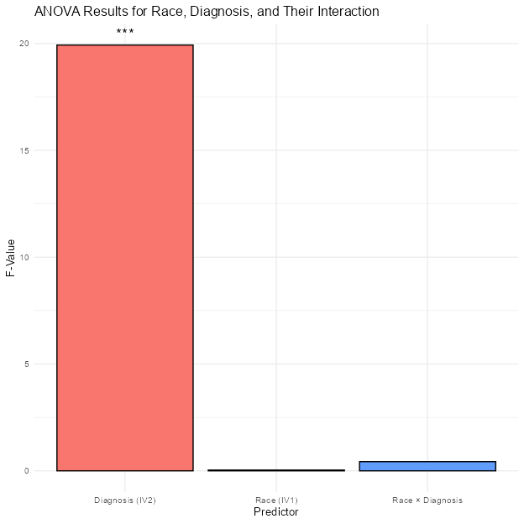

*Note*. The plot shows F-values for each predictor in the ANOVA model. Higher F-values indicate a stronger effect on the dependent variable.

### Mean Stigma Scores by Diagnosis

Figure 2

Effect of Mental Illness Diagnosis on Social Distance Stigma.

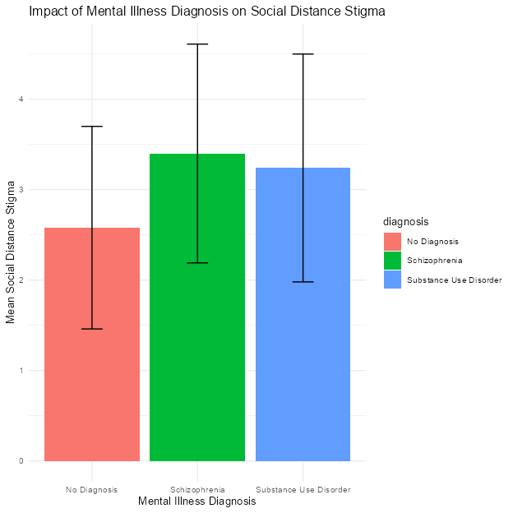

*Note*. The plot shows mean social distance stigma scores by diagnosis, with error bars representing standard deviation.

**Figure 2** shows the effect of mental illness diagnosis on social distance stigma. The mean stigma scores for each diagnosis are as follows:No Diagnosis: 2.58 (SD = 1.12), Schizophrenia: 3.4 (SD = 1.21),Substance Use Disorder: 3.24 (SD = 1.26)

The results indicate that individuals with schizophrenia (M = 3.4) and substance use disorder (M = 3.24) experience higher levels of social distance stigma compared to those with no diagnosis (M = 2.58). These differences were statistically significant.

# Discussion

This study explored how race and mental illness diagnosis impact the stigmatization of homeless individuals, specifically focusing on social distance. The results revealed that race did not significantly affect social distance stigma, suggesting that race was not a key factor in determining social distance in this context. However, the diagnosis of mental illness had a significant impact on social distance. Individuals with schizophrenia and substance use disorder were perceived as more socially distant than those with no diagnosis, supporting the hypothesis that mental illness contributes to higher levels of social distance stigma.

The absence of a significant interaction between race and diagnosis further highlights that mental illness plays a larger role in shaping social distance perceptions than race. This finding suggests that, when it comes to social distance, mental illness may be a more prominent factor than race in the stigmatization of homeless individuals.

These findings underscore the importance of addressing mental illness as a key determinant in social stigma, particularly in the context of homelessness. Further research is needed to explore how these factors interact in other forms of stigmatization and to investigate the role of mental illness across different populations.

# References

Corrigan, P. W., Kuwabara, S. A., & O’Shaughnessy, J. (2009). The Public Stigma of Mental Illness and Drug Addiction: Findings from a Stratified Random Sample. *Journal of Social Work*, *9*(2), 139–147. <https://doi.org/10.1177/1468017308101818>

Corrigan, P., Markowitz, F. E., Watson, A., Rowan, D., & Kubiak, M. A. (2003). An Attribution Model of Public Discrimination Towards Persons with Mental Illness. *Journal of Health and Social Behavior*, *44*(2), 162. <https://doi.org/10.2307/1519806>

Frost, R. (2020). *Homelessness Was on the Rise, Even before the Pandemic Joint Center for Housing Studies.*

Gattis, M. N., & Larson, A. (2016). Perceived racial, sexual identity, and homeless status-related discrimination among Black adolescents and young adults experiencing homelessness: Relations with depressive symptoms and suicidality. *American Journal of Orthopsychiatry*, *86*(1), 79–90. <https://doi.org/10.1037/ort0000096>

Markowitz, F. E., & Syverson, J. (2021). Race, Gender, and Homelessness Stigma: Effects of Perceived Blameworthiness and Dangerousness. *Deviant Behavior*, *42*(7), 919–931. <https://doi.org/10.1080/01639625.2019.1706140>

Weisz, C., & Quinn, D. M. (2018). Stigmatized identities, psychological distress, and physical health: Intersections of homelessness and race. *Stigma and Health*, *3*(3), 229–240. <https://doi.org/10.1037/sah0000093>